**Abstract Factory**

Lets you produce families of related objects without specifying their concrete classes.

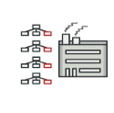 Eg. – This f++++

|  |  |
| --- | --- |
|  |  |
|  | |
| Eg. Switch condition. Call center/login/ | Eg.- go to restraurant-> order to waiter->write order-> handover to chef-> order in queue->make order->waiter serve order Here written order is command. Eb.- multiple save buttons works same so all follow the same command and pass it to parent class |
|  |  |
|  |  |
|  |  |
|  |  |
|  |  |